Lecture 5
Override – dynamic - runtime
Overload – static – compile time
Poly+ morph = diff behaviour + form
Overriding method cannot be stricter than overriden method.
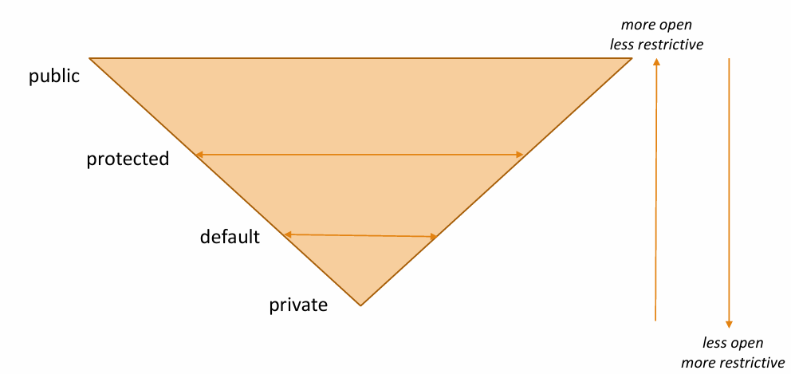
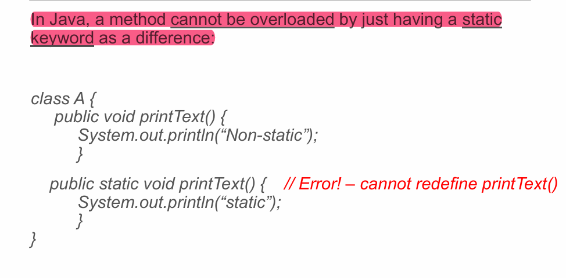
In Java, the final keyword helps define objects and types as unmodifiable. Like const in C#.
Final objects and arrays can change their values using their own methods and indices. But they can’t have new reference assigned. So mutables can be changed. Immutables like string not.
Final variable can be initialized in instance initializer.
Finals are used for define members as constants. So for making that constant available through all classes, without having to create object from that class(instantiation), you have to use static keyword as well.
public static final int MAX_VALUE = 25;
Using final keyword in method declaration prevents its overriding.
Declaring a class as final means the class cannot be extended other class.

Object class - Any Java class instance can be assigned to an Object variable. Object class is superclass of every class in Java.
Object obj = new Dog();
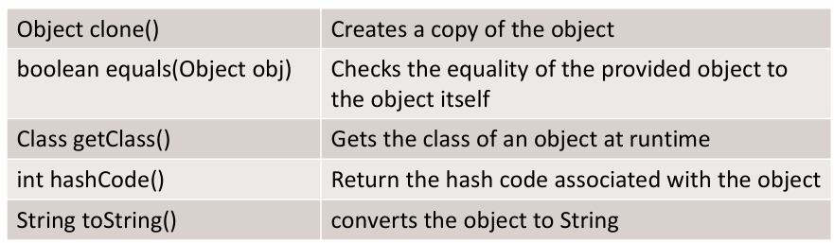
.clone() can be used to clone objects. When using that method, you have to cast to the corresponding class.
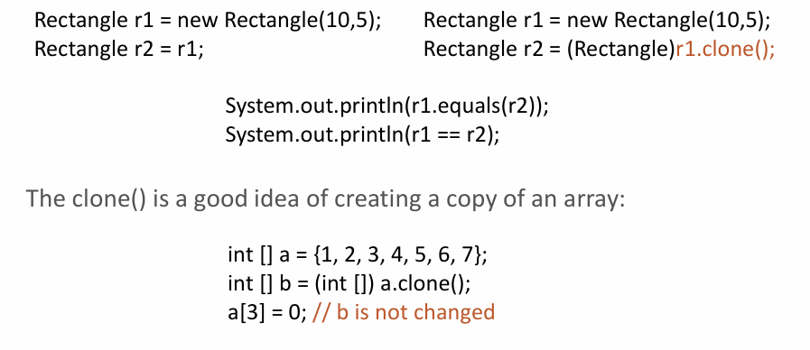
Passing string as parameter to the method
class test {
static void change(String s) {
s = "Hello";
}

public static void main(String[] args) {
String str = "Hi";
change(str);
System.out.println(str); // Output will be "Hi" because strings are immutable in Java and the reference to the original string is not changed in the change method.
}
}

Abstract classes
Unimplemented – leaving body empty
A class with an abstract method shall be defined as abstract itself.
An abstract class cannot be instantiated.
The child of abstratct class has to implement the abstract method of parent. But if child is abstract too, then it doesn’t have to.
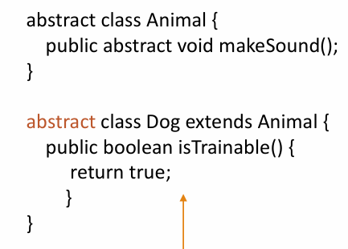

Interfaces
Interfaces do not have instance variables (bc cannot be instantiated)
Interfaces shall not implement any code
Interfaces do not have constructors
The default access modifier for interface methods is public
The default access modifier for interface itself is default.
The methods that implement an interface must be declared public.
If class does not fully implement the methods required by the interface, then that class must be declared as abstract.
An interface can extend another interface.
Variables defined in interfaces are implicitly(altdan altdan default) made as final and static, and they have to have an initial value. Or it will raise error.
Interface can have static,private,default methods. Default methods can have implementation.

Enumerations
Enums are implicitly final, which means you cannot extend or implement them.
Declaration and comparision of enum:
enum Response { YES, NO, CANCEL };
Response userResponse;
….
if (userResponse == Response.YES) { …}

values() method returns an array that contains a list of the enumeration constants.
valueOf(String str) method returns the enumeration constant whose value corresponds to the string passed in str.
Color col = Color.valueOf(“Orange”);
System.out.println(“There is ”+col+” in our list”);

Foreach for enum:
Color colors[] = Color.values();
for (Color c : colors)
System.out.println(c);

Enums can have methods and constructors.
The position of the enumeration constant can be obtained by calling the ordinal() method. We can’t set their number value as we do in other languages, for that you can use this approach:
enum Fruit {
Apple(2), Banana(2), Grapes(3), Plum(4);

private int price;

Fruit() {
this.price = -1;
}

Fruit(int p) {
this.price = p;
}

int getPrice() {
return price;
}
}

Fruit f = Fruit.Apple;

Enumerations might have abstract methods too. Then each enumeration constant must override it.
enum Response {
YES {
public String asAzerbaijani() {
return "BƏLİ";
}
},
NO {
public String asAzerbaijani() {
return "XEYR";
}
},
CANCEL {
public String asAzerbaijani() {
return "LƏĞV";
}
};

public abstract String asAzerbaijani();
}

Sealing classes
A sealed class is a class which allows only a specific subclasses to extend it.
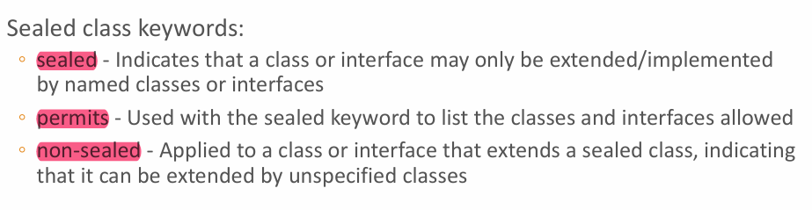
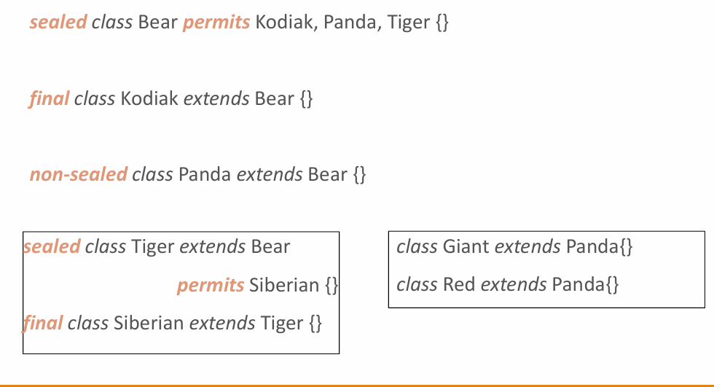

Records – is used for having less getter. Syntax:
public record Account(String customerName, double balance) { }
in records, compiler implicitly inserts
- All arguments constructor (data types and the order of the fields in the constructor are exactly the same as they are defined in the record)
- Getters (without a get or is prefix)
- Implementations of toString(), equals() and hashCode()
Records are implicitly final, i.e., they cannot be extended.
Records are immutable, that is why there are no setter methods.
If some validations need to be added in the constructor, constructor can be manually added to the records, for making restrictions (for example no age<0 exists)
Long contsructor (a constructor that sets all the fields) – like in normal class
Compact constructor (a constructor that only performs validation and necessary transformations)

Monetary Operations – operations that are done on money
They are initialized as Strings:
import java.math.BigDecimal;
BigDecimal amount = new BigDecimal(”22.15");
To output the value of BigDecimal toString() or toPlainString() methods can be used.
BigDecimal is also immutable.
BigInteger & BigDecimal can be used when it is required to store and process arbitrary large numbers.

